Asia-China-Coin-6-Round-H6.8 R3

FD367 Inscription on right obv. reversed from FD 368.

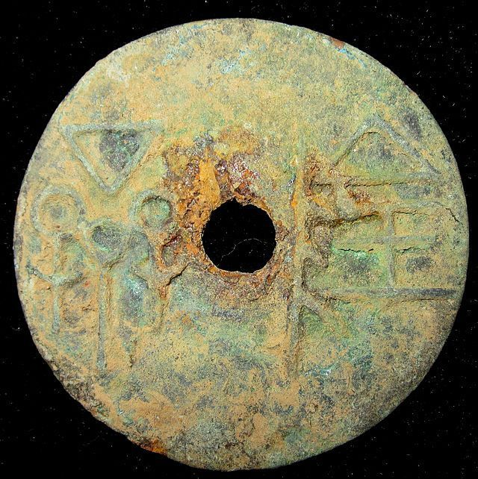

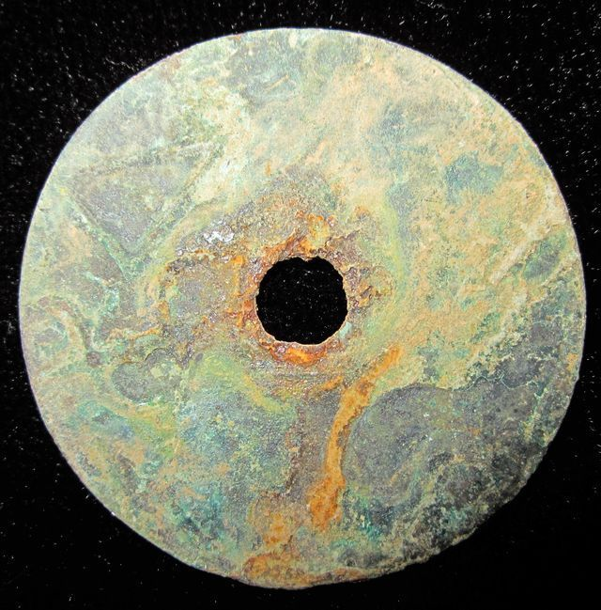

# WarringStatesPeriod WEI NATION WAR CITY MINT MONEY BRONZE ROUND COIN济阴圜钱1.5"RARE

### Seller information

|  |  |
| --- | --- |
|  |  |

[cnrelics](http://myworld.ebay.com/cnrelics?_trksid=p2047675.l2559) ([18](http://feedback.ebay.com/ws/eBayISAPI.dll?ViewFeedback&userid=cnrelics&iid=151198705295&ssPageName=VIP:feedback&ftab=FeedbackAsSeller&rt=nc&_trksid=p2047675.l2560) )

100% Positive feedback

[Follow this seller](http://www.ebay.com/itm/WarringStatesPeriod-WEI-NATION-WAR-CITY-MINT-MONEY-BRONZE-ROUND-COIN-1-5-RARE-/151198705295?_trksid=p2047675.l2557&ssPageName=STRK%3AMEWNX%3AIT&nma=true&si=5L4Tlo08dyY9pQflhUEb6fWvMTI%253D&orig_cvip=true&rt=nc)

[See other items](http://www.ebay.com/sch/cnrelics/m.html?item=151198705295&nma=true&rt=nc&si=5L4Tlo08dyY9pQflhUEb6fWvMTI%253D&orig_cvip=true&ssPageName=STRK%3AMEWNX%3AIT&_trksid=p2047675.l2562)

Top of Form

## Item Information

Item condition:

--not specified

“Rust on the body,Museum quality”

Ended:

Jan 04, 2014 18:01:04 PST

Winning bid:

US $49.99

[ [1 bid](http://offer.ebay.com/ws/eBayISAPI.dll?ViewBids&_trksid=p2047675.l2565&rt=nc&item=151198705295) ]

[Add to list](http://cgi1.ebay.com/ws/eBayISAPI.dll?MakeTrack&_trksid=p2047675.l1360&rt=nc&item=151198705295&sourcePage=4340&ssPageName=VIP:watchlink:top:en&SubmitAction.AddToListVI=x&wt=bca21a2181a5521ece3750a7232fe565)

|  |  |  |  |
| --- | --- | --- | --- |
|  | Join **eBay Bucks** and earn **%** back on this item. [See conditionsfor eBay Bucks - opens in a new window or tab](http://pages.ebay.com/rewards/terms.html?ssPageName=STRK:VI:LNLK:TCS) | | |
|  | | New customers get $10 back on 1st purchase Subject to credit approval.[See terms](https://apply.billmelater.com/apply?guid=F2W40R2E&assetId=NBRVI0114) |  |

Shipping:

$10.00 Economy Shipping from outside US | [See details](http://www.ebay.com/itm/WarringStatesPeriod-WEI-NATION-WAR-CITY-MINT-MONEY-BRONZE-ROUND-COIN-1-5-RARE-/151198705295?_trksid=p2047675.l2557&ssPageName=STRK%3AMEWNX%3AIT&nma=true&si=5L4Tlo08dyY9pQflhUEb6fWvMTI%253D&orig_cvip=true&rt=nc" \l "shpCntId)

See details about international shipping here.

Item location:

BeiJing, China

Ships to:

Worldwide

Bottom of Form